# CS 255 System Design Document Template

This template lays out all the different sections that you need to complete for Project Two. Each section has guidance to prompt your thinking. You will need to continually reference the interview transcript as you work to make sure that you are addressing your client’s needs. There is no required length for the final document. Instead the goal is to complete each section based on what your client’s needs are. Remove this note when you are finished, and replace all bracketed text with the relevant information.

## UML Diagrams

### UML Use Case Diagram

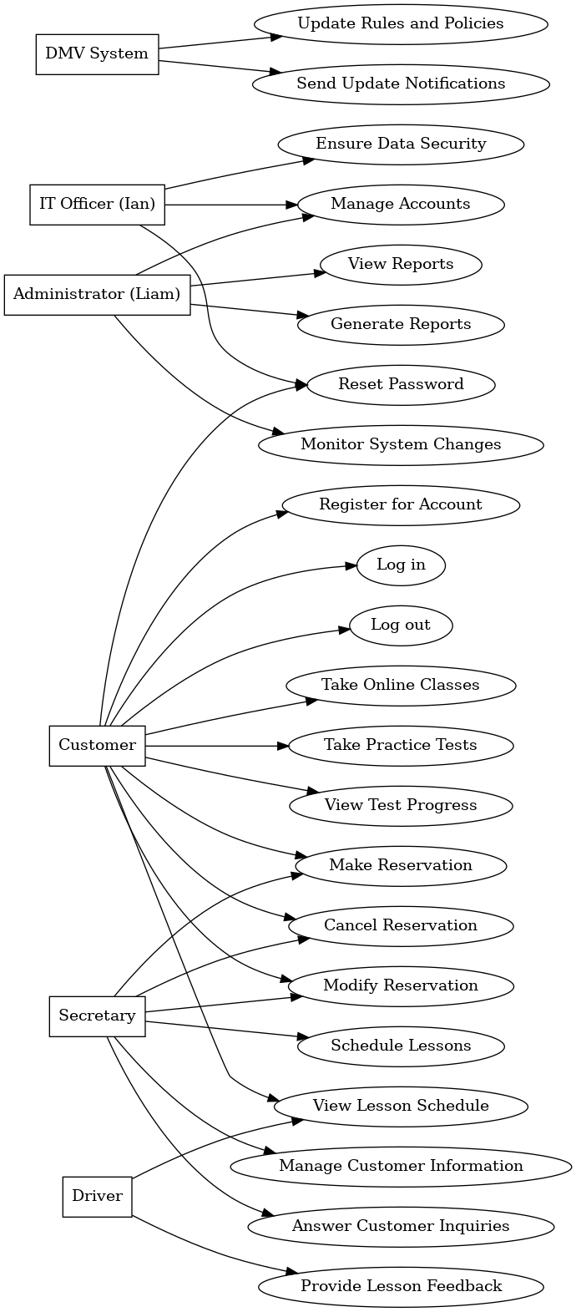

### UML Activity Diagrams

*Schedule an appointment*

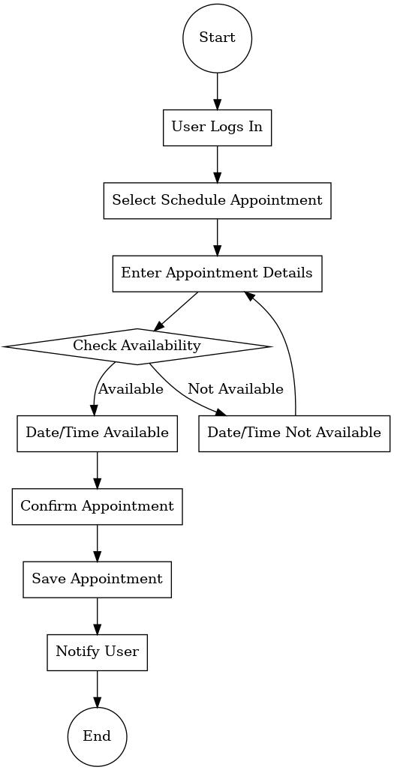

*Reset Password*

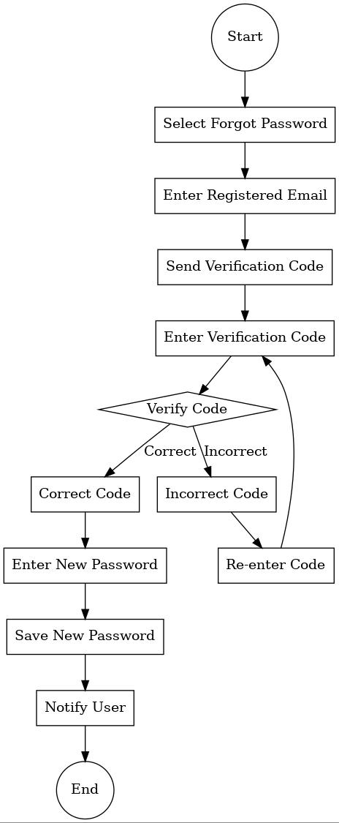

### UML Sequence Diagram

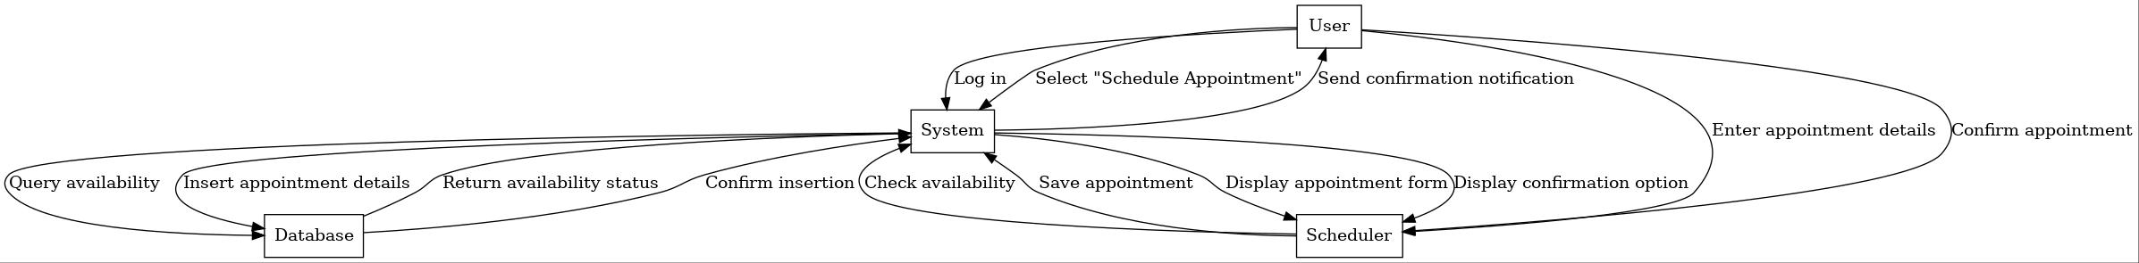

### UML Class Diagram

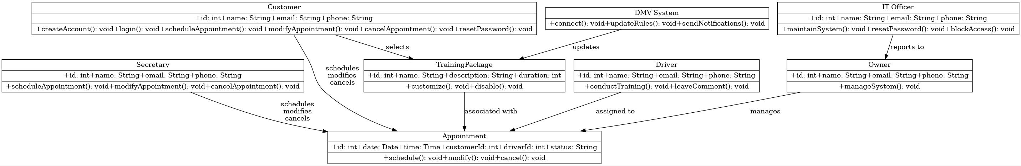

## Technical Requirements

Hardware:

We need powerful web servers to host the DriverPass application, ensuring it's always available. Database servers are essential for managing and storing user data, appointments, and training packages. Backup servers are required to protect against data loss. For administrative tasks, we need computers for the owner, IT officer, and secretary, equipped with standard office software and internet access. Additionally, drivers and customers need mobile devices like tablets and smartphones to use the system on the go. Reliable routers, switches, and secure Wi-Fi access points will ensure smooth connectivity.

Software:

For the servers, we can use either Linux or Windows Server. Admin workstations can run Windows, macOS, or Linux. We need software like Apache or Nginx to serve the DriverPass application. Databases like MySQL, PostgreSQL, or SQL Server will help manage user information. Development tools like Visual Studio Code or Eclipse are necessary for building and maintaining the application, and Git will help with version control. We’ll use HTML, CSS, JavaScript, and frameworks like React.js or Angular for the front end, and Node.js, Python, or Java for the back end. SQL will be used for database queries. Security software includes firewalls, SSL/TLS certificates, and antivirus programs to keep everything secure.

Infrastructure:

We’ll use cloud services like AWS, Azure, or Google Cloud for hosting and backups, offering flexibility and scalability. A reliable, high-speed internet connection is crucial for smooth online interactions. A VPN will provide secure remote access for administrative staff. Regular automated backups will protect our data, and a disaster recovery plan will ensure we can restore data if something goes wrong. Finally, we’ll regularly update all systems and software to keep everything secure and compliant with data protection regulations like GDPR or CCPA.

By fulfilling these requirements, the DriverPass system will run smoothly, securely, and reliably, meeting the needs of the business and its users.